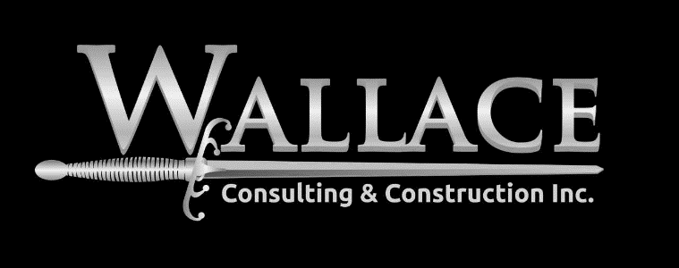

Construction Management

We will manage the team! All of our professionals have first-hand experience with in-field construction management. We feel there is no substitute for actual experience. This proficiency gives us the expertise to analyze all of the information we receive and all of the actual conditions. It also gives us the knowledge to deal with most construction issues in the most efficient way possible because we have seen them before.
​Prior to construction is the time to make use of that experience and solve the problems before they are on the drawings or built. We will work with you and your team to identify your goals, so that we can then coordinate the design team to plan the project around achieving those goals. We will help you with every step along the way. Often times we start with budgeting before a site has even been selected. Then we help you identify the key divers for cost, schedule impacts and other specific goals that you have. Prior to leasing or purchasing, we will review the site with you to help identify challenges and advantages of various options. We will then fine tune budgets and provide lease/contract reviews to help you make the right deal. We will put together the correct design team for your project.

